Brainstorm

**TIP**

You can select a sticky note and hit the pencil [switch to sketch] icon to start drawing!

& idea prioritization

Use this template in your own brainstorming sessions so your team can unleash their imagination and start shaping concepts even if you're not sitting in the same room.

**Before you collaborate**

A little bit of preparation goes a long way with this session. Here’s what you need to do to get going.

**10 minutes**

1. **Team gathering**

Define who should participate in the session and send an invite. Share relevant information or pre-work ahead.

1. **Set the goal**

Think about the problem you'll be focusing on solving in the brainstorming session.

1. **Learn how to use the facilitation tools**

Use the Facilitation Superpowers to run a happy and

**1**

# Define your problem statement

What problem are you trying to solve? Frame your problem as a How Might We statement. This will be the focus of your brainstorm.

**5 minutes**

TEAM ID: PNT2022TMID22598

**Getting back customer feedback for betterment and refinement of the chatbot system.**

**PROBLEM**

**How might we make online fashion shopping smarter?**

**2**

# Brainstorm

Write down any ideas that come to mind that address your problem statement.

**10 minutes**

# GRACELIN C

**Accept input from customer on their preference and skin color for better recommendation.**

**Integrated customer Feedback collecting system**

**Advertise best deals and offers on that day.**

**JANANI L**

**Large and Varied collection of fashion apparels in database for more personalised search results.**

**3**

# Group ideas

Take turns sharing your ideas while clustering similar or related notes as you go. Once all sticky notes have been grouped, give each cluster a sentence-like label. If a cluster is bigger than six sticky notes, try and see if you and break it up into smaller sub-groups.

**20 minutes**

**Simple and easy UI to enable end-user for seamless and smart purchase experience.**

**4**

# Prioritize

Your team should all be on the same page about what's important moving forward. Place your ideas on this grid to determine which ideas are important and which are feasible.

**20 minutes**

**After you collaborate**

You can export the mural as an image or pdf to share with members of your company who might find it helpful.

## Quick add-ons

1. **Share the mural**

**Share a view link** to the mural with stakeholders to keep them in the loop about the outcomes of the session.

1. **Export the mural**

Export a copy of the mural as a PNG or PDF to attach to emails, include in slides, or save in your drive.

**10 minutes** to prepare

**Suggesting latest trend based fashion outfit.**

**1 hour** to collaborate

**2-8 people** recommended

productive session.

[**Open article**](https://support.mural.co/en/articles/2113740-facilitation-superpowers)

**Cloud integration of Chatbot for quick and efficient recommendation system.**

## Key rules of brainstorming

To run an smooth and productive session

# SUBASHINI V

**SNEHA S**

## Keep moving forward

**Strategy blueprint**

Define the components of a new idea or strategy.

[**Open the template**](https://app.mural.co/template/e95f612a-f72a-4772-bc48-545aaa04e0c9/984865a6-0a96-4472-a48d-47639307b3ca)

**Customer experience journey map**

Stay in topic. Defer judgment.

Encourage wild ideas. Listen to others.

## Importance

**Get many inputs such as: Gender, Age class, Dress size, Dress category, Color preference, Price filter etc.**

If each of these

Understand customer needs, motivations, and obstacles for an experience.

[**Open the template**](https://app.mural.co/template/b7114010-3a67-4d63-a51d-6f2cedc9633f/c1b465ab-57af-4624-8faf-ebb312edc0eb)

**Separating the type of user as Admin and Customer for providing a separate UI.**

Go for volume. If possible, be visual.

tasks could get

done without any difficulty or cost, which would have the most positive impact?

**Easy monitoring of customers, products as well as feedback database in dedicated Admin dashboard**

**Promoting best deals and Offers**

**Strengths, weaknesses, opportunities & threats**

Identify strengths, weaknesses, opportunities, and threats (SWOT) to develop a plan.

[**Open the template**](https://app.mural.co/template/6a062671-89ee-4b76-9409-2603d8b098be/ca270343-1d54-4952-9d8c-fbc303ffd0f2)

[**Share template feedback**](https://muralco.typeform.com/to/CiqaHVat?typeform-source=app.mural.co)

**Use python , Flask and Docker for seamless integration**

**Personalised clothing recommendation**

**Separate UI dashboards for common user and admin.**

**Use a Chatbot for Smart recommendations**

**TIP**

Participants can use their cursors to point at where sticky notes should go on the grid. The facilitator can confirm the spot by using the laser pointer holding the **H key** on the keyboard.

[**Share template feedback**](https://muralco.typeform.com/to/CiqaHVat?typeform-source=app.mural.co)

## Feasibility

Regardless of their importance, which tasks are more feasible than others? (Cost, time, effort, complexity, etc.)

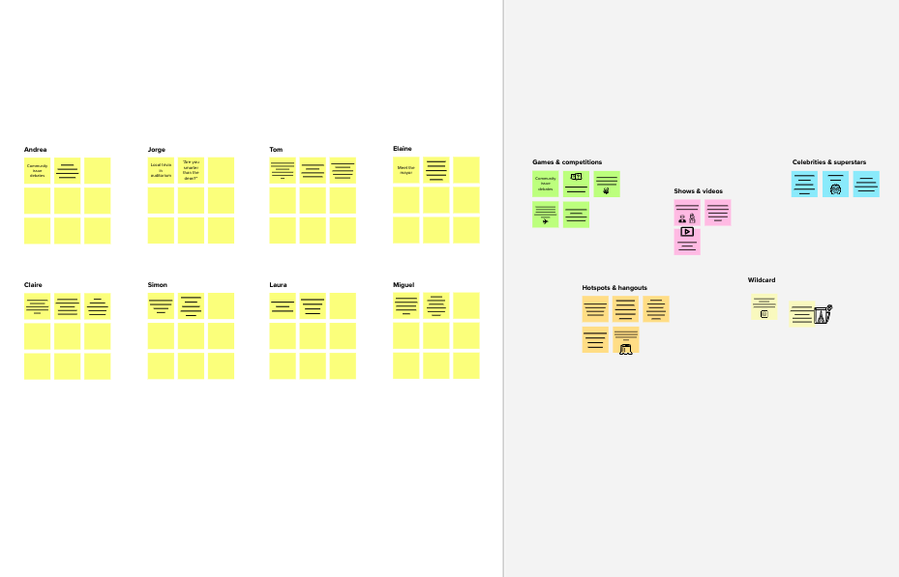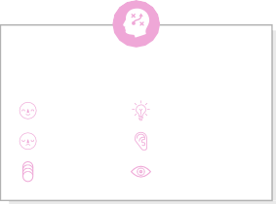

**Template**

**Need some inspiration?**

See a finished version of this template to kickstart your work.

[**Open example**](https://app.mural.co/template/e5a93b7b-49f2-48c9-afd7-a635d860eba6/93f1b98d-b2d2-4695-8e85-7e9c0d2fd9b9)